I choose the data set that describes the relationship between GDP and M2(money supply and the definition would be given later), the potential purpose of this research is to find that if the amount of M2 would influence the amount of GDP

And find the data

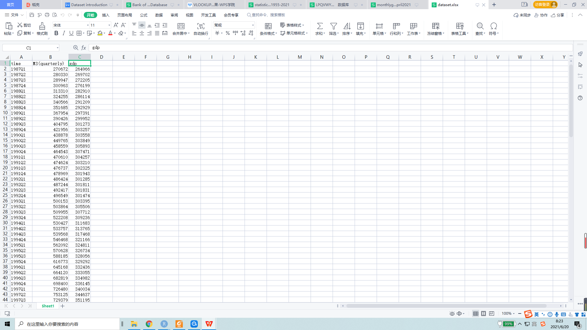

Then import them into R to get a draft

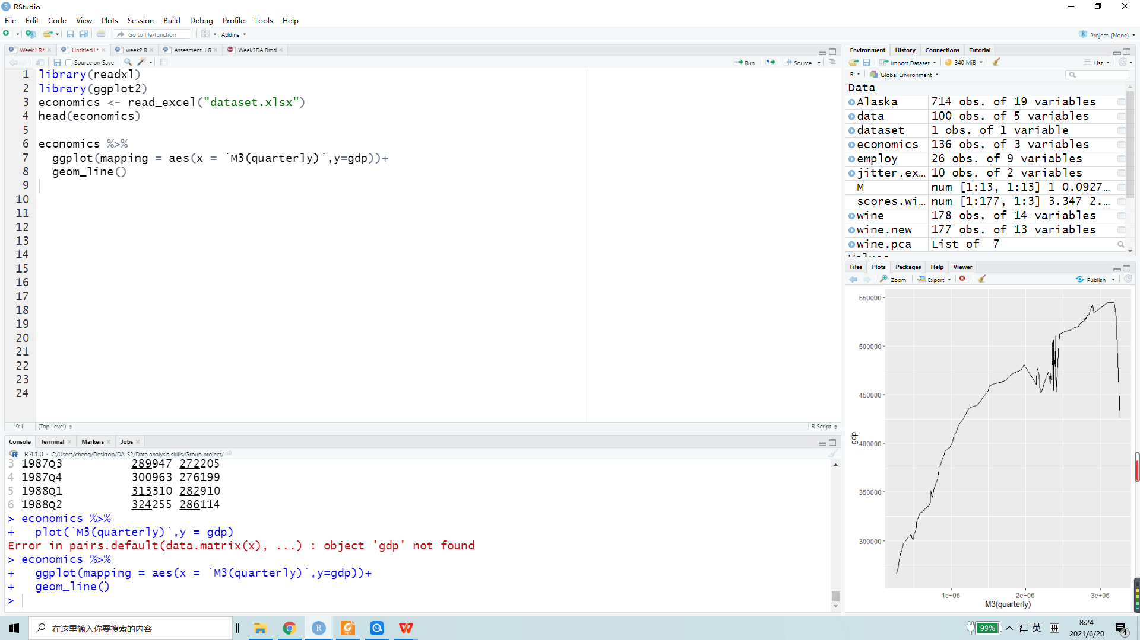

Waiting for future discussion...